We’ve had a lovely September here at Jelly Bears. We have celebrated World Coconut Day, by smelling and feeling some, we’ve enjoyed being Pirates for a day for Talk Like a Pirate Day- see our Facebook for some great photos. We are looking forward to October where we will be learning more about Autumn, finding out about Rosh Hashanah and National Smile Day.

liketexture and used wooden elephants to explore in it.

**Jelly Beans Highlights**

**Jelly Babies and Tots Highlights**

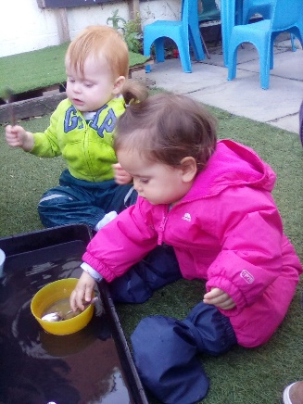

We have said "goodbye and good luck!" to our preschool leavers and given a warm "welcome!" to our new children starting their learning journey in the Jelly Beans Room.

Jelly Babies have been experiencing some water play where we practiced using spoons to scoop the water up.

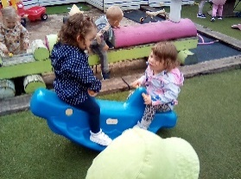

We have been getting to know each other, making new friends and enjoying some Autumn sunshine and activities!

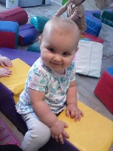

We have also enjoyed the soft play where we were rolling and balancing on the different shaped blocks and knocked over some tall towers.

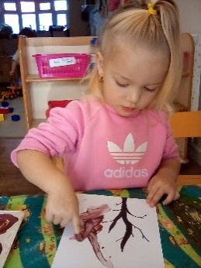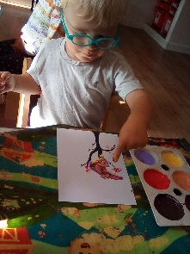

Autumn tree painting - we have been finding out about the changing seasons and mixing paint colours to create new ones.

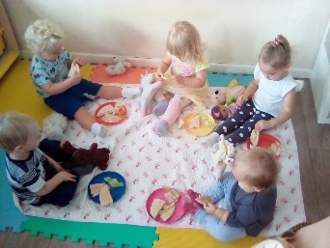

Jelly Tots had a Teddy Bears Picnic as a part of National Teddy Bear Day, we all sat very nicely while we shared some yummy wraps and grapes with our teddies.

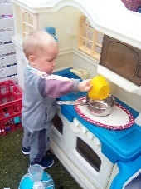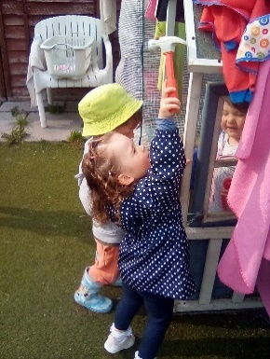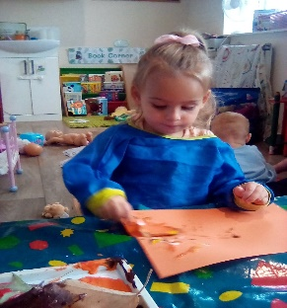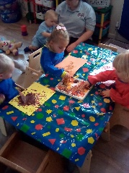

We have been making the most of the sunny days with lots of garden play  - using tools to  'fix' the play house, cooking in our outdoor kitchen and small world water play.

We have also been doing lots of Autumnal artwork to explore the change of season and what happens to nature around this time. We used some fallen leaves that we found in the garden to create paintings, looking at what marks they left behind.

**Wendy** – Room Lead, DSL

**Antonia-** E.Y.E **Jessie-** E.Y.E

**Leah** – 0-2 Floor Lead

**Bridie** - E.Y.E **Amelia** – E.Y.E **Zoe** E.Y.E

**Kim** – Managing Director, DSL, SENCo (office based)

**Lydia** – Deputy Manager (Jelly Beans Room/ office based)

**Jorja** Level 3 Apprentice **Helen** –Cook **Kim. W** -Lunchtime Assistant & Bank Staff **Caroline** – Bank Staff

We have explored a variety of arts and crafts this month from finger print butterflies to toilet roll fireworks.